​library book inventory &borrowing management system

1. Cover Page
Include project title, your name, roll number, course, instructor, and submission date.
Project Title: Library Book Management System
Submitted by: Bachamolla Sridhar
Roll Number: 25MIP10013
Course:Introduction to problem solving
Instructor: Dr. A.v.r Mayuri
Date: 23/11/2025

2. Introduction
The Library Book Management System is a Python-based program that allows users to manage library books using a CSV file for storage. Core features include adding, viewing, searching, borrowing, returning, updating, and deleting books.

3. Problem Statement
Libraries often struggle with manual tracking of books, leading to errors, lost records, and inefficient book lending and returning. There is a need for a simple, automated system for managing book inventory and transactions.

4. Functional Requirements
- Add new books with unique IDs.
- View all books in the library.
- Search for books by ID or title.
- Borrow and return books, updating quantity.
- Update book details or quantity.
- Delete books from the system.
- CSV file-based storage for persistence.

5. Non-functional Requirements
- User-friendly command-line interface.
- Reliable read/write operations on CSV file.
- Error handling for invalid inputs and file access.
- Portability across OS with Python installed.
- Fast execution for small/medium datasets.

6. Design Diagrams
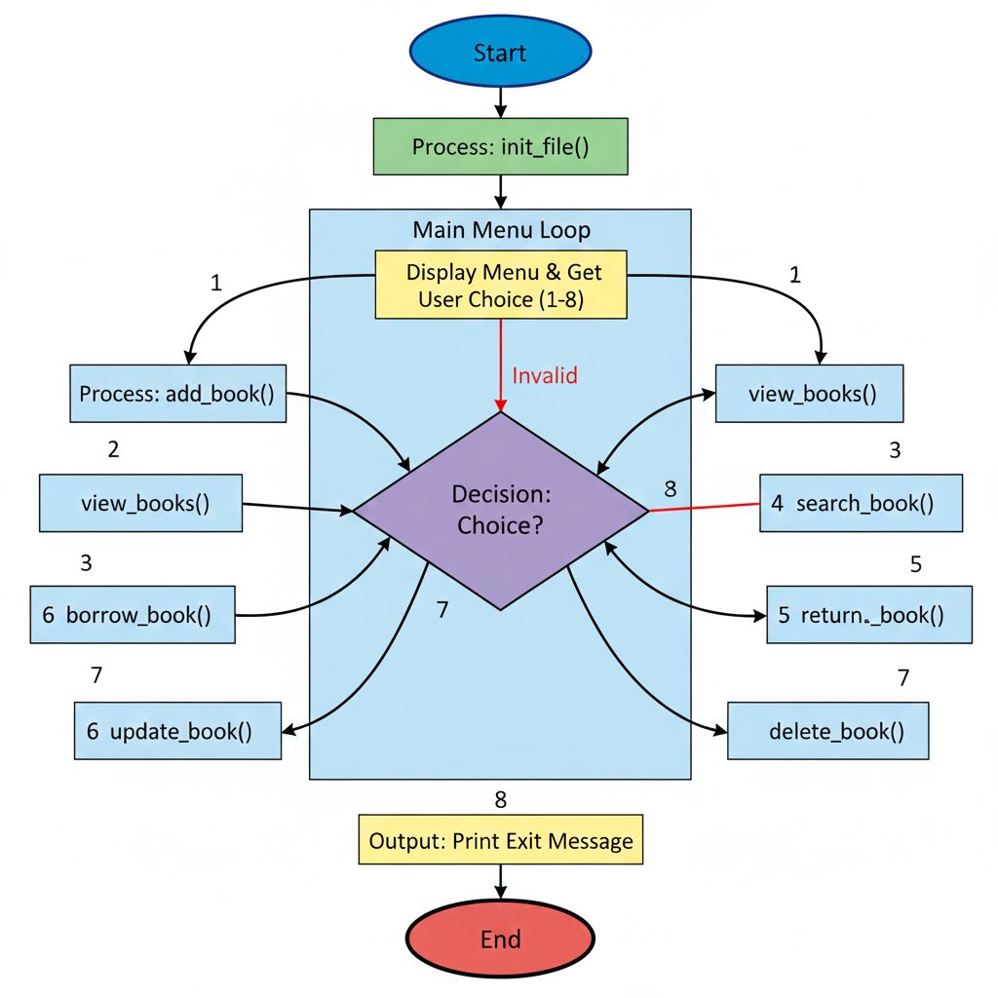

7. Design Decisions & Rationale
- Chose CSV for storage due to simplicity and ease of management.
- Command-line interface for accessibility.
- Modular functions to separate concerns and improve maintainability.

8. Implementation Details
- Implemented in Python using csv and os modules.
- Each feature mapped to a function: add_book(), view_books(), etc.
- Handles errors and guides user for correct input.
- Data persisted in "library.csv".

9. Screenshots / Results
- Screenshot of main menu.
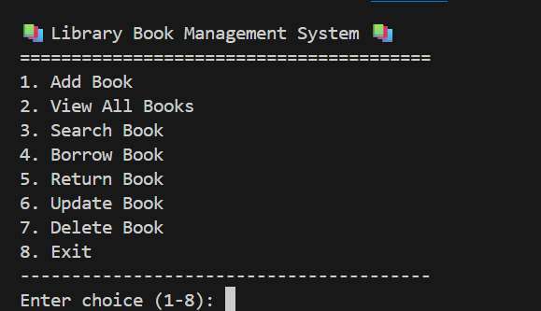
- Before and after adding a book.
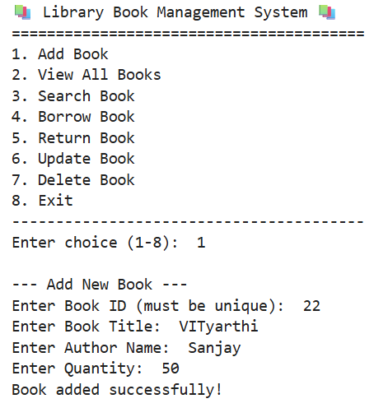
- Book search and borrow operation.
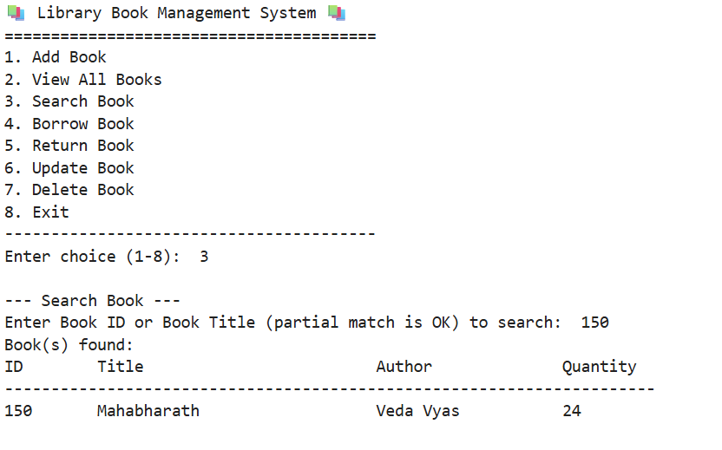

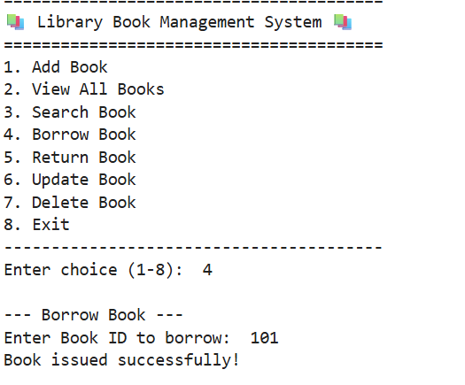
- Book return and quantity update.
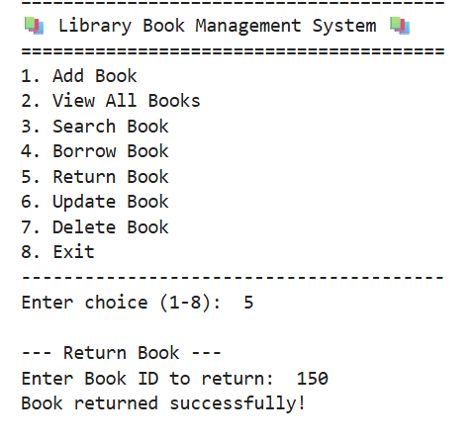
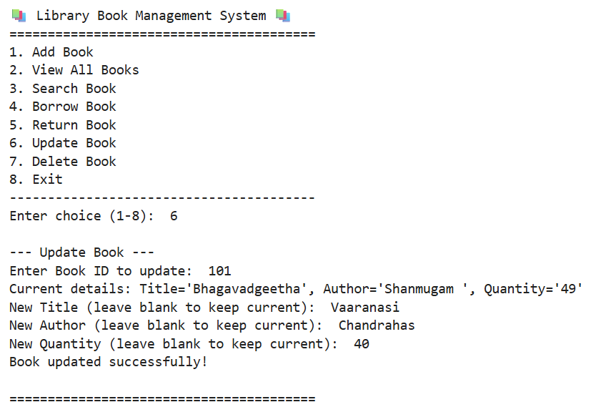

10. Testing Approach
- Manual testing for each feature covering typical usage and edge cases (e.g., duplicate IDs, invalid quantity).
- Tested error handling for file absence and invalid data.
- Verified persistent storage after program exit.

11. Challenges Faced
- Ensuring unique book IDs.
- Handling concurrent file access.
- User input validation.
- Managing edge cases in borrow/return logic.

12. Learnings & Key Takeaways
- Importance of data validation and error handling.
- Benefits of modular code organization.
- Practical experience with CSV file operations in Python.

13. Future Enhancements
- GUI-based interface.
- Advanced search (by author, genre).
- User authentication and tracking individual borrowers.
- Integration with larger database (SQLite, MySQL).
- Report generation for usage statistics.

14. References
- Python documentation
- csv module documentation
- Project guidelines from Vityarthivityarthi.proj.report.jpg​
- Online tutorials for file handling in Python

